Story Of RMS Web Contest

This is a HSC Math Contest Platform . The Authority Can Set A Room .   
In Each Room :  
There will be a Set Of Math Question On Some Specific Topic (HSC). There Will be a Group Of Student who will perform the Quiz/Contest . And There will be a Set of Moderator who will set up the Math Questions.

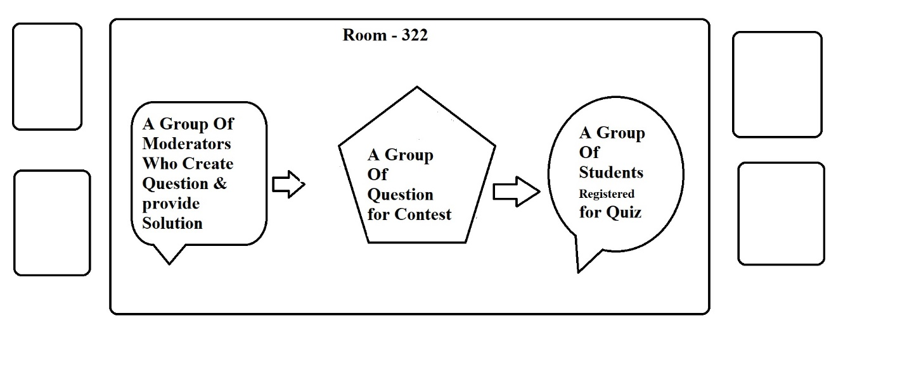  
During The Math Contest the student who solve the math first will get a position for each solution . After finishing the contest they will get a rating and also they will get a national ranking .And The round will keep on going.

After Each Contest , There will be a Tutorial ( video link / blog ) for each Contest.  
Students Can read The blog and also they can provide the solutions also in the comment section .And Students can reply them or react in the blog also.

